Android Architecture

**android architecture** or **Android software stack** is categorized into five parts:

1. linux kernel
2. native libraries (middleware),
3. Android Runtime
4. Application Framework
5. Applications

Let's see the android architecture first.

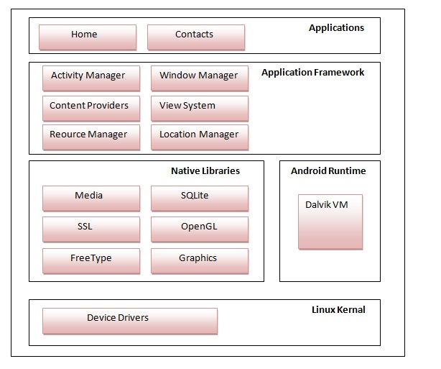

## 1) Linux kernel

It is the heart of android architecture that exists at the root of android architecture. **Linux kernel** is responsible for device drivers, power management, memory management, device management and resource access.

## 2) Native Libraries

On the top of linux kernel, their are **Native libraries** such as WebKit, OpenGL, FreeType, **SQLite**, Media, C runtime library (libc) etc.

The WebKit library is responsible for browser support, SQLite is for database, FreeType for font support, Media for playing and recording audio and video formats.

## 3) Android Runtime

In android runtime, there are core libraries and DVM (Dalvik Virtual Machine) which is responsible to run android application. DVM is like JVM but it is optimized for mobile devices. It consumes less memory and provides fast performance.

## 4) Android Framework

On the top of Native libraries and android runtime, there is android framework. Android framework includes **Android API's** such as UI (User Interface), telephony, resources, locations, Content Providers (data) and package managers. It provides a lot of classes and interfaces for android application development.

## 5) Applications

On the top of android framework, there are applications. All applications such as home, contact, settings, games, browsers are using android framework that uses android runtime and libraries.

# Android Core Building Blocks

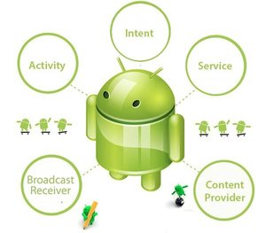

An android **component** is simply a piece of code that has a well defined life cycle e.g. Activity, Receiver, Service etc.

The **core building blocks** or **fundamental components** of android are activities, views, intents, services, content providers, fragments and AndroidManifest.xml.

#### Activity

An activity is a class that represents a single screen. It is like a Frame in AWT.

#### View

A view is the UI element such as button, label, text field etc. Anything that you see is a view.

#### Intent

Intent is used to invoke components. It is mainly used to:

* Start the service
* Launch an activity
* Display a web page
* Display a list of contacts
* Broadcast a message
* Dial a phone call etc.

#### Service

Service is a background process that can run for a long time.

There are two types of services local and remote. Local service is accessed from within the application whereas remote service is accessed remotely from other applications running on the same device.

#### Content Provider

Content Providers are used to share data between the applications.

#### Fragment

Fragments are like parts of activity. An activity can display one or more fragments on the screen at the same time.

#### AndroidManifest.xml

It contains informations about activities, content providers, permissions etc. It is like the web.xml file in Java EE.

#### Android Virtual Device (AVD)

It is used to test the android application without the need for mobile or tablet etc. It can be created in different configurations to emulate different types of real devices.